Order Of Service

Singing: Psalm 119a—CW page 109

Reading: Psalm 106:1-18

Opening Hymn: CW 432

Reading: Hebrews 3:1-19

Request Hymn: CW Supplement 760

Reading: Luke 7:11-17

Sermon Hymn: CW 169

Sermon Text: Acts 7:51-53

Resisting The Holy Ghost

Prayer

The Apostles’ Creed, TLH page 12

Holy Communion

The Lord's Prayer

The Blessing

Closing Hymn: CW 422

************

Koinonia Hour

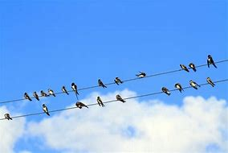

Ready To Head South

Water
Of
Life

1 September 2024

W A T E R O F L I F E

Independent Christian Church—Conservative Lutheran Doctrine

Worship Service: 9:30 a.m.

Larry Cooper, Pastor E-Mail address:
lcooper@wateroflife.cc
Web Site:
www.wateroflife.cc

* * * * * * * * * * * * * * * * * * * * * * * * * * *

Sermon Text: Acts 7:51-53

Resisting The Holy Ghost

* * * * * * * * * * * * * * * * * * * * * * * * * * *

51 Ye stiffnecked and uncircumcised in heart and ears, ye do always resist the Holy Ghost: as your fathers did, so do ye.
52 Which of the prophets have not your fathers persecuted? and they have slain them which shewed before of the coming of the Just One; of whom ye have been now the betrayers and murderers:
53 Who have received the law by the disposition of angels, and have not kept it.

